HDOC-31
PROBLEM STATEMENT: Write a menu-driven C program to perform the following operations on a given 2D array:
- Find the sum of all elements
- Find the sum of each row and store the results in an array
- Find the transpose of the matrix
- Exit
ITEM | DETAILS
INPUT | Number of rows, number of columns, matrix elements and menu choice
OUTPUT | Total sum, row-wise sums with row-sum array, transpose
CONCEPTS | 2D array, 1D array, nested loops, switch case, do-while loop
ALGORITHM:
- Start
- Read the number of rows and columns
- Read all matrix elements using nested loops
- Display the menu:
- Sum of all elements
- Sum of each row and store in an array
- Transpose of a matrix
- Exit
- Read the user’s choice
- Use switch case:
Case 1: Initialize sum = 0, add every matrix element and display sum
Case 2: For each row, calculate its sum, store it in rowSum[i], display each row sum, then display the row sum array.
Case 3: Print matrix[j][i] using reversed row/column loops to display transpose.
Case 4: exit the program.
Default: display “Invalid choice”
- Repeat the menu until choice 4 is selected.
- Stop.
TEST CASE TABLE:
TEST TABLE | INPUT | EXPECTED OUTPUT | RESULT
1 | 2*3 matrix: 1 2 3/ 4 5 6; choice1 | Sum = 21 | Pass
2 | 2*3 matrix: 1 2 3/4 5 6; choice2 | Row sums = 6, 15; Array = [6,15] | Pass
3 | 2*3 matrix: 1 2 3/ 4 5 6; choice3 | Transpose: 1 4/ 2 5/ 3 6/ | Pass
4 | Any valid matrix; choice4 | Program exits | Pass

C PROGRAM:
#include <stdio.h>

int main() {
int rows, cols, i, j, choice;
int matrix[10][10], rowSum[10];
int sum;

printf("Enter the number of rows and columns: ");
scanf("%d %d", &rows, &cols);

printf("Enter the matrix elements:\n");
for (i = 0; i < rows; i++) {
for (j = 0; j < cols; j++) {
scanf("%d", &matrix[i][j]);
}
}
do {
printf("\n--- MENU ---\n");
printf("1. Sum of all elements\n");
printf("2. Sum of each row\n");
printf("3. Transpose of matrix\n");
printf("4. Exit\n");
printf("Enter your choice: ");
scanf("%d", &choice);
switch (choice) {
case 1:
sum = 0;
for (i = 0; i < rows; i++) {
for (j = 0; j < cols; j++) {
sum += matrix[i][j];
}
}
printf("Sum of all elements = %d\n", sum);
break;
case 2:
printf("Row sums:\n");
for (i = 0; i < rows; i++) {
rowSum[i] = 0;
for (j = 0; j < cols; j++) {
rowSum[i] += matrix[i][j];
}
printf("Sum of row %d = %d\n", i + 1, rowSum[i]);
}
printf("The row-sum array contains: [");
for (i = 0; i < rows; i++) {
printf("%d", rowSum[i]);
if (i < rows - 1)
printf(", ");
}
printf("]\n");
break;
case 3:
printf("Transpose of the matrix:\n");
for (j = 0; j < cols; j++) {
for (i = 0; i < rows; i++) {
printf("%d\t", matrix[i][j]);
}
printf("\n");
}
break;
case 4:
printf("Exiting program...\n");
break;
default:
printf("Invalid choice. Please enter 1 to 4.\n");
}
} while (choice != 4);
return 0;
}
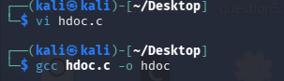
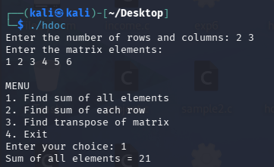
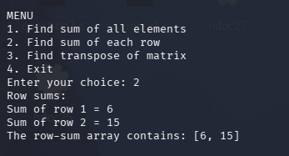
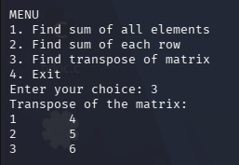
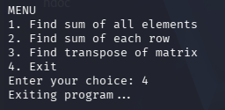
CONCLUSION: The program successfully performs all required matrix operations using a menu-driven switch-case structure.

